# Composite Sketching: Survey on Sketch to Face Generator

##### **Avirup Rakshit, Aditya Yadav, Anukalp Jain, Rivana Shridharan**

*Department of Artificial Intelligence and Machine Learning,

Dayananda Sagar College of Engineering

DOI

***Abstract*-** Current advancements in deep image-to-image translation techniques have made it possible to generate face images quickly from freehand sketches. However, existing solutions often struggle with overfitting to the sketches, requiring professional-level sketches or even edge maps as input.

In essence, this method treats input sketches as soft constraints, enabling us to generate high-quality face images even from rough or incomplete sketches. The usability of our tool extends to non-artists as well, while still providing fine-grained control over shape details. To validate the effectiveness of our system, we conducted qualitative and quantitative evaluations, demonstrating its superior generation capabilities compared to existing and alternative solutions. Furthermore, a user study confirmed the usability and expressiveness of our system.

In summary, our approach offers a promising solution for generating face images from sketches. By implicitly modeling the shape space and utilizing soft constraints, we achieve high-quality results, making the tool accessible to a wider range of users while maintaining control over shape details. The system's superiority is supported by evaluations and user feedback

***Index Terms***- Conditional Generative Adversarial Network, Pix2Pix[6], Pix2PixHD[6], Human-centered computing, Image processing, image-to-image translation, feature embedding, sketch-based generation, face synthesis

1. Introduction

T

he paper discusses the demanding situations and proposed solutions for generating sensible human face pix from sketches using deep mastering techniques. most existing methods deal with sketches as constant constraints and consciousness on reconstructing lacking texture or shading facts, which requires sketches just like area maps of real pictures. this may be tough for customers with restrained drawing talents.

To cope with this difficulty, the proposed method pursuits to study a space of attainable face sketches implicitly from real face sketch pics. by way of locating the closest point on this space to approximate an enter sketch, the synthesis of extra practicable pictures becomes feasible even with tough or incomplete sketches, while keeping the characteristics represented within the sketches.

It also highlights the broader idea of computerized picture-to-photograph translation, in which the purpose is to translate one illustration of a scene into every other the usage of deep learning.

Convolutional neural networks (CNNs) had been extensively used for photo prediction, but designing powerful loss features for CNNs remains a guide procedure. The textual content introduces Generative Adversarial Networks (GANs) as a solution, where GANs study a loss characteristic primarily based on distinguishing actual and pretend pix. This approach discourages blurry outputs and can be carried out to numerous responsibilities that traditionally required extraordinary loss features.

the focal point of the paper is on conditional GANs (cGANs)[1], which analyze a conditional generative model for picture-to-picture translation tasks. The paper demonstrates that cGANs[1] can produce affordable results across a huge range of problems. It also presents a simple framework and analyzes the impact of different architectural alternatives.

typical, the paper addresses the challenges of producing realistic face photographs from sketches and explores the potential of conditional GANs as a trendy-motive answer for image-to-photo translation duties.

1. IDENTIFY, RESEARCH AND COLLECT IDEA

The proposed approach entails several modules for producing realistic face pix from input sketches. The process starts with the Component Embedding (CE)[7] module, which decomposes the face caricature into 5 components: left eye, right eye, nose, mouth, and the rest. each element is represented through a neighborhood feature embedding obtained through an auto-encoder. The latent feature descriptors are discovered with a dimensionality of 512, which has been determined to offer higher effects compared to decrease-dimensional representations.

The Feature Mapping (FM)[7] module projects the enter sketch onto the component manifolds to beautify plausibility. To synthesize a realistic photograph, one approach is to convert the feature vectors of the projected manifold factors returned into sketches the use of the learned decoders. Then, the strip-to-photograph synthesis is finished, and the final vectors are fused to create a complete face photograph. but, this technique often ends in inconsistencies in nearby information and global patterns.

The photo Synthesis (IS)[7] module makes use of a conditional GAN architecture to transform the mixed feature maps into a practical face image. The generator includes an encoding component, a residual block, and a interpreting unit. The discriminator operates in a multi-scale manner to seize excessive-stage correlations among parts.

The training system entails two levels. In stage I, handiest the CE[7] module is skilled the use of aspect sketches. each man or woman auto-encoder is skilled in a self-supervised manner, minimizing the mean square mistakes (MSE) between the enter sketch photograph and the reconstructed photo. In stage II, the entire community is skilled in an cease-to-cease way. The FM[7] and IS[7] modules are educated together, with the parameters of the skilled thing encoders constant. further to the GAN loss, an L1 loss is incorporated to manual the generator and make certain pixel-sensible best. The perceptual loss is used inside the discriminator to compare the high-level difference among real and generated photos.

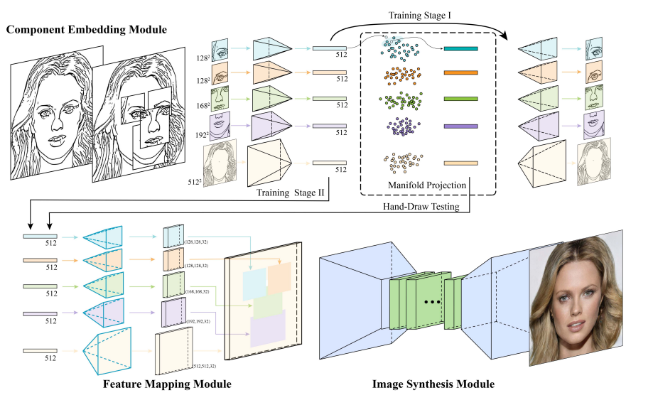

Fig. 1. Illustration of our network architecture. The upper half is the Component Embedding module. We learn feature embeddings of face components using individual auto-encoders. The feature vectors of component samples are considered as the point samples of the underlying component manifolds and are used to refine an input hand-drawn sketch by projecting its individual parts to the corresponding component manifolds. The lower half illustrates a sub-network consisting of the Feature Mapping (FM) and the Image Synthesis (IS) modules. The FM module decodes the component feature vectors to the corresponding multi-channel feature maps (H x W x 32), which are combined according to the spatial locations of the corresponding facial components before passing them to the IS module.[7]

For a user-pleasant experience, the ShadowDraw[4] method is applied. It makes use of the idea of the use of the to be had information samples to create a generalized image as a shadow on which the consumer could draw and feature a widespread concept where the functions need to be defined.

It works in degrees, within the first degree, edges are extracted from the picture the use of an extended facet detector technique stimulated by using perceptual studies. This approach normalizes part magnitudes, weights them primarily based on local curvature, and sums them along the length of the threshold. The resulting facet response captures the brink period and diploma of curvature in place of depth gradients. the brink pictures are stored the use of run-period encoding.

inside the 2nd stage, patch descriptors are computed for each side image. aspect positions are decided with the aid of finding maxima in responses perpendicular to the edge direction. The patches used for computing neighboring descriptors overlap by way of 50%, resulting in 81 descriptors over a set grid of patches. each patch is encoded the use of a simplified version of the BiCE[4] descriptor, which encodes aspect positions and orientations. A three-dimensional histogram is used with discrete side orientations, positions perpendicular to the brink, and positions tangent to the threshold. The histogram is binarized, resulting in a final descriptor with 432 binary bits.

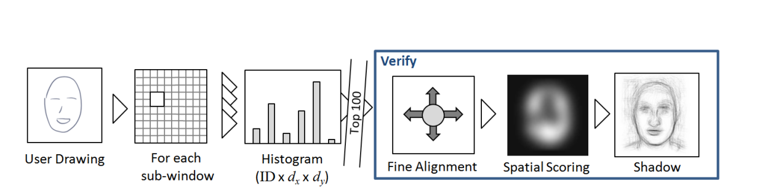

Fig 2: An outline of rhe online processing pipeline. Given a user's strokes, sketches are computed for each sub-window, and matching votes are accumulated in a histogram. The top 100 matching images are aligned. scored. and weighted to generate the final shadow image.[4]

1. OUTPUT, USER INTERFACE AND USABILITY

Let's assume we've a fixed of comic strip snap shots S used to train the function embeddings for face components. We count on that each issue has an underlying low-dimensional manifold known as Mc, and we agree with that factors in the characteristic area of each thing lie on or close to this manifold.

while we've an enter comic strip s, we want to make it greater manageable as a human face via projecting its issue capabilities to the respective issue manifolds. To achieve this, we adopt a retrieval-and-interpolation technique based on the locally linear assumption.

For a given factor c, we start with the aid of finding the okay nearest samples inside the function space Fc the usage of Euclidean distance. We determined that okay=10 gives great face plausibility and variant. allow Kc denote this set of nearest samples. We then goal to reconstruct s^c, the c-th thing of the enter comic strip, through locating a linear aggregate of its pals in Kc that minimizes the reconstruction mistakes.

To verify the neighborhood continuity of the underlying manifolds, we randomly select a sample from S and its nearest neighbor in the corresponding characteristic space for the c-th element. We carry out linear interpolation among those element sketches within the function area and reconstruct the interpolated factor sketches the usage of the learned decoder Dc. The reconstructed outcomes display easy changes between the consecutive interpolated component sketches, indicating the feasibility of our descriptor interpolation approach.

normal, this technique permits us to task the factor features of an input cartoon onto the respective component manifolds, improving its plausibility as a human face.

This method is stimulated from the Pix2Pix[6] version.

1. EARLY WORKS ON THE TOPIC

let's assume we've a set of cartoon photographs S used to educate the characteristic embeddings for face components. We count on that every issue has an underlying low-dimensional manifold called Mc, and we accept as true with that points in the feature space of each element lie on or near this manifold.

when we've an enter caricature s, we need to make it more workable as a human face by projecting its thing functions to the respective issue manifolds. To achieve this, we undertake a retrieval-and-interpolation approach based on the locally linear assumption[1].

For a given element c, we begin via finding the ok nearest samples within the characteristic space Fc the use of Euclidean distance. We located that ok=10 offers satisfactory face plausibility and variant. permit Kc denote this set of nearest samples. We then goal to reconstruct s^c, the c-th issue of the input cartoon, through locating a linear mixture of its neighbors in Kc that minimizes the reconstruction error.

To affirm the local continuity of the underlying manifolds, we randomly pick out a pattern from S and its nearest neighbor in the corresponding characteristic area for the c-th element. We carry out linear interpolation among these two thing sketches inside the feature space and reconstruct the interpolated component sketches using the found out decoder Dc. The reconstructed effects display clean changes between the consecutive interpolated component sketches, indicating the feasibility of our descriptor interpolation technique.

typical, this technique allows us to task the thing functions of an enter cartoon onto the respective thing manifolds, improving its plausibility as a human face.

This approach is inspired from the Pix2Pix[6] version.

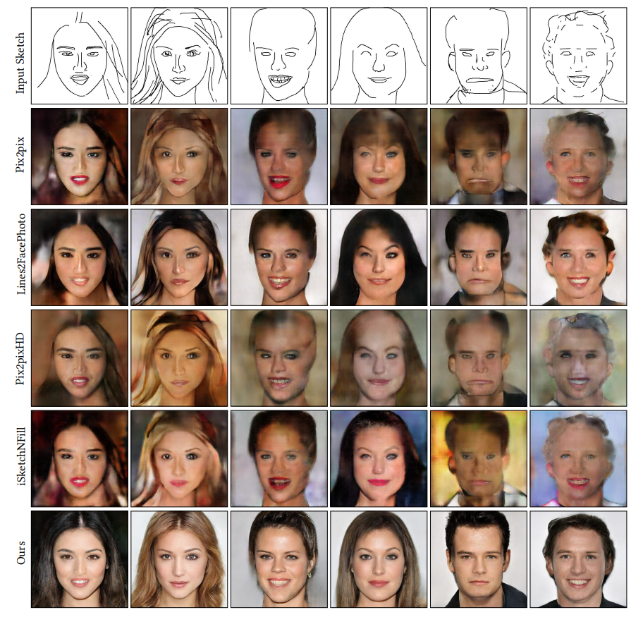

Fig. 3. Gallery of input sketches and synthesized results in the usability study.[7]

1. APPLICATION

Our system is versatile and can be adapted to various applications. In this section, we introduce two specific applications: face morphing and face copy-paste.

1. Face Morphing[7]

Traditional face morphing algorithms typically rely on key point-level correspondence between two face images to guide the interpolation process. Our approach offers a simple yet effective method for face morphing. We decompose a pair of source and target face sketches from the training dataset into five components. These component sketches are then encoded as feature vectors in their respective feature spaces. By performing linear interpolation between the corresponding feature vectors of the components, we generate intermediate face images using the FM and IS modules. Examples of face morphing achieved through our method. The results demonstrate smooth transformations in identity, expression, and even highlight effects.

2. Face Copy-Paste[7]

Traditional copy-paste methods typically rely on seamless stitching techniques applied to colored images. However, there are scenarios where the local color hue is not relevant. To address this, we propose recomposing face components to create new faces while maintaining overall color and lighting consistency. This is accomplished by encoding face component sketches, which may come from different individuals, as feature vectors and then combining them using the FM and IS modules to create new faces. This technique can be employed to replace components of existing faces with corresponding components from another source or combine components from multiple individuals. We are able to showcase several synthesized new faces created by recombining eyes, nose, mouth, and other facial regions from four source sketches. Our image synthesis sub-network effectively resolves inconsistencies between face components from different sources, considering both lighting and shape aspects.

This completes the entire process required for widespread of research work on open front. Generally all International Journals are governed by an Intellectual body and they select the most suitable paper for publishing after a thorough analysis of submitted paper. Selected paper get published (online and printed) in their periodicals and get indexed by number of sources.

1. CONCLUSION

This survey introduces a novel deep learning framework for generating realistic face images from rough or incomplete freehand sketches. The approach follows a local-to-global strategy, starting with the decomposition of a sketched face into components. Each component is refined by projecting it onto component manifolds defined by existing samples in the feature spaces. The refined feature vectors are then mapped to feature maps for spatial combination, and the combined feature maps are translated into realistic images. This approach enables local editing and facilitates training with relatively small-scale datasets. Compared to existing sketch-to-image synthesis methods, our approach outperforms by not requiring high-quality input edge maps or sketches. A user study confirms the usability of our system. We also explore applications such as face morphing and face copy-paste.

While our current implementation allows for flexibility in handling individual components, it may introduce compatibility issues, particularly for symmetric features like eyes. To address this, future work may incorporate symmetry loss or enforce the use of paired eyes from the same samples. Additionally, our system primarily focuses on refining individual component errors rather than fixing layout errors. We are interested in modeling spatial relations between facial components to address layout issues in the future.

Our system currently takes black-and-white rasterized sketches as input and does not provide control over color or texture in synthesized results. To improve usability and enable smoother transitions, we propose introducing a color control mechanism by incorporating color constraints as additional hints or guidance in the input or latent space. Color control would also benefit applications such as face morphing and copy-paste.

As with other learning-based approaches, the performance of our system relies on the amount of training data available. Although the dimensionality of component-level manifolds might be low, our feature vectors are high-dimensional, resulting in sparse sampling. Future work aims to increase the scale of the training data and more accurately model the underlying component manifolds. This would enhance our system's ability to handle non-frontal faces, faces with accessories, and improve result diversity by introducing random noise to the input. Explicitly learning these manifolds and providing intuitive exploration tools in a 2D space is an interesting avenue for further investigation.

While our current system is specifically designed for faces, extending our approach to support the synthesis of objects in other categories poses an interesting and challenging problem that warrants future exploration.

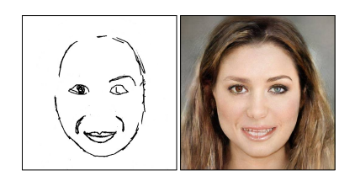

Fig. 21. A less successful example. The eyes in the generated image are of

different colors. For the sketched mouth, it is slightly below an expected

position, leading to a blurry result for this component.[7]

Acknowledgment

1. James Arvo and Kevin Novins. 2000. Fluid Sketches: Continuous Recognition and Morphing of Simple Hand-Drawn Shapes. In Proceedings of the 13th annual ACM symposium on User interface software and technology. ACM, 73–80W.-K. Chen, *Linear Networks and Systems* (Book style)*.* Belmont, CA: Wadsworth, 1993, pp. 123–135.
2. Volker Blanz and Thomas Vetter. 1999. A Morphable Model for the Synthesis of 3D Faces. In Proceedings of the 26th Annual Conference on Computer Graphics and Interactive Techniques. ACM, 187âĂŞ194
3. Daniel Dixon, Manoj Prasad, and Tracy Hammond. 2010. iCanDraw: using sketch recognition and corrective feedback to assist a user in drawing human faces. In Proceedings of the SIGCHI Conference on Human Factors in Computing Systems. ACM, 897–906J. Wang, “Fundamentals of erbium-doped fiber amplifiers arrays (Periodical style—Submitted for publication),” *IEEE J. Quantum Electron.*, submitted for publication.
4. Yong Jae Lee, C Lawrence Zitnick, and Michael F Cohen. 2011. Shadowdraw: real-time user guidance for freehand drawing. ACM Trans. Graph. 30, 4, Article Article 27 (2011), 10 pages.
5. Ran Yi, Yong-Jin Liu, Yu-Kun Lai, and Paul L Rosin. 2019. APDrawingGAN: Generating Artistic Portrait Drawings from Face Photos with Hierarchical GANs. In IEEE Conference on Computer Vision and Pattern Recognition (CVPR). IEEE, 10743–10752
6. Isola, Phillip & Zhu, Jun-Yan & Zhou, Tinghui & Efros, Alexei. (2017). Image-to-Image Translation with Conditional Adversarial Networks(Pix2Pix). 5967-5976. 10.1109/CVPR.2017.632.
7. Chen, Shu-Yu & Su, Wanchao & Gao, Lin & Xia, Shihong & Fu, Hongbo. (2020). DeepFaceDrawing: deep generation of face images from sketches. ACM Transactions on Graphics. 39. 10.1145/3386569.3392386.

Authors

**First Author** – Author name, qualifications, associated institute (if any) and email address.

**Second Author** – Author name, qualifications, associated institute (if any) and email address.

**Third Author** – Author name, qualifications, associated institute (if any) and email address